Assignment 08
Part 01:
- Try Every Point Covered in the Lecture for the Calculator operations.

Part 02:
- Considering the Code Below, Write Down the Body of all Listed Methods and Properties and Constructor:

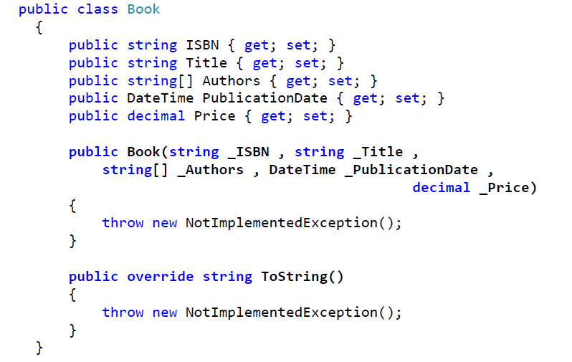

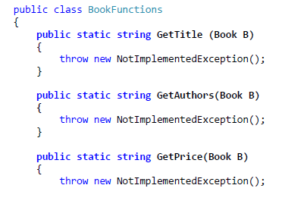
}
}

- You need to parameterize ProcessBooks function to accept BookFunctions Methods using following cases:
- Create User Defined Delegate with the same signature of methods existed in Bookfunctions class.
- Use the Proper build in delegate.
- Anonymous Method (GetISBN).
- Lambda Expression (GetPublicationDate).

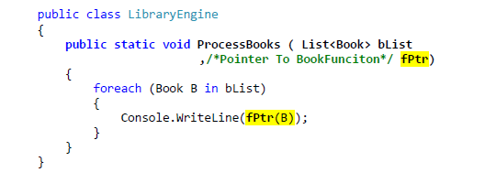

Part 03:
Write Unit Testing for all functions with at least two test case Sceniro.

